**Design**

**Main Stakeholders**:

* **Students**: The end-users of the app, will actually be using it to select majors, plan their studies, and manage their academic schedules, financial aid, etc.
* **Academic Advisors**: Faculty or staff members assist students in making academic choices. Will be interested in its applications and how they can use it to help students.
* **University Administration**: Admin oversees overall academics that stuff like advisory and major selection falls under. Similar stakes as advisors but on a higher, less involved level.

**Stakeholder Interview Questions:**

**Student Interview:**

* Do you face any challenges when thinking about major selection?
* How do you currently plan your academic schedule?
* What features would you like to see in an academic advisor application?
* What information is most important for you to have access to when you are looking into financial aid?

**Advisor Interview:**

* Do you face any challenges when advising students about major selection?
* How do you currently assist students in creating study plans?
* What features would you like to see in an academic advisor application?
* Do you think students are aware of all the resources available to them?

I interviewed 2 GMU students as student stakeholders, as I was unable to find an example of the other two.

**Stakeholder 1: Freshman**

Challenges: The student mentioned that they felt overwhelmed by major options when choosing when during application season, did not know where to look after when considering changes during freshman year.

Academic Schedule Planning: Student plans study plan for semesters with advisor and on own through GMU catalog. Student refers to their semesterly schedule from registration website transferred to Notion.

Desired Features: While no longer needing it, student expressed interest in a major selection assistant, as well as full year study planner.

Financial Aid: Student would prefer easier format for figuring out eligibility for financial aid.

**Stakeholder 2: Senior**

Challenges: Student did not necessarily have trouble choosing major, but comments that even if they did, they did not know where to look anyway.

Academic Schedule Planning: Student also plans semester schedules on own, does not consult advisors. Student generates schedules on own in excel after retiring of GMU patriot scheduler application.

Desired Features: Student expressed interest in a clean and efficient scheduler like former GMU patriot scheduler.

Financial Aid: Student did not require much financial aid so could not answer, but did say GMU website was adequate.

**Formal Argument**

Students often struggle with many issues that may be too difficult to deduce from existing campus resources on their own but do not warrant a scheduled meeting with an advisor. Examples include selecting a major that aligns with their interests, planning their academic schedules, and financial aid inquiries. Academic advisors, on the other hand, lack efficient and concise tools to guide students to help them make their own informed decisions about their academic careers. There is a need for an "Academic Advisor" application that simplifies major selection, generates personalized study plans, and provides students with easy access to financial aid information and other resources. This application will help students make better and informed academic decisions on their own through an easy-to-use self-service platform and reduce the workload for academic advisors.

**Implementation**

**Index Page and AI Feature Requirement:**

**Requirement 1: “Selecting a major based on abilities, marketability, etc.”**

**Requirement 2: “ Suggest an overall study plan based on a chosen major."**

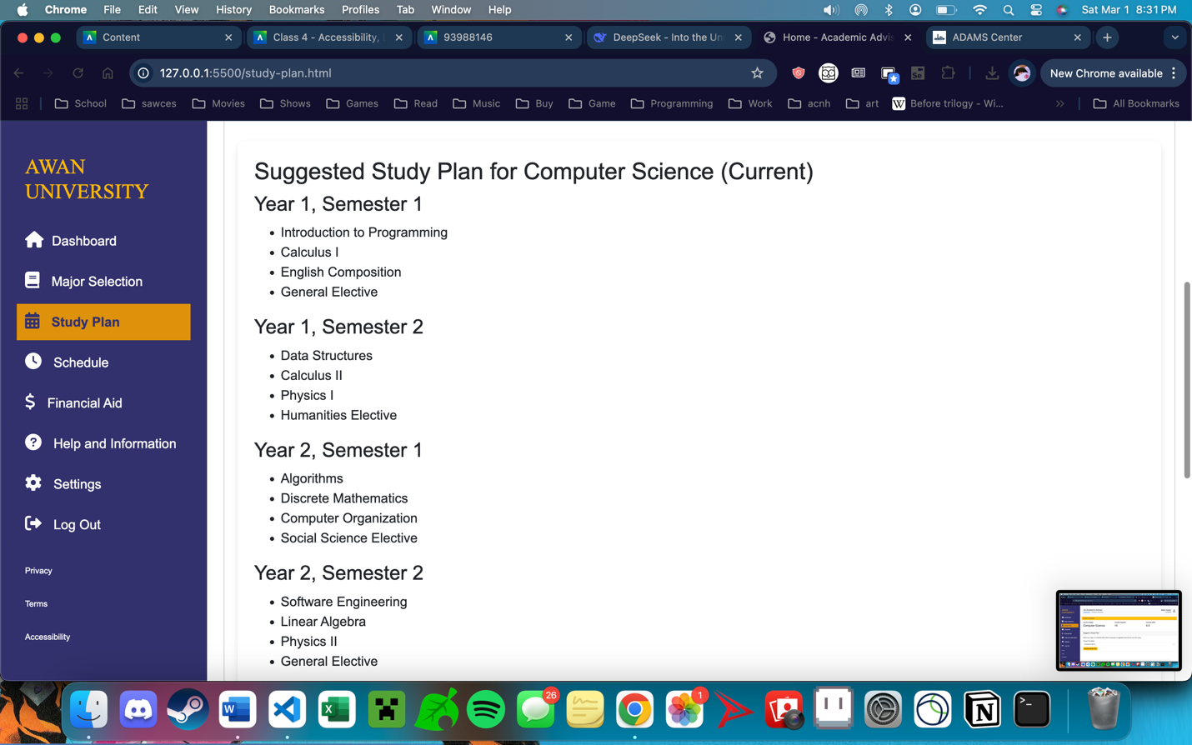

**Requirement 3: “Set up a schedule for an upcoming semester based on the student's progress so far.”**

**Requirement 4: “**Help with financial aid.”

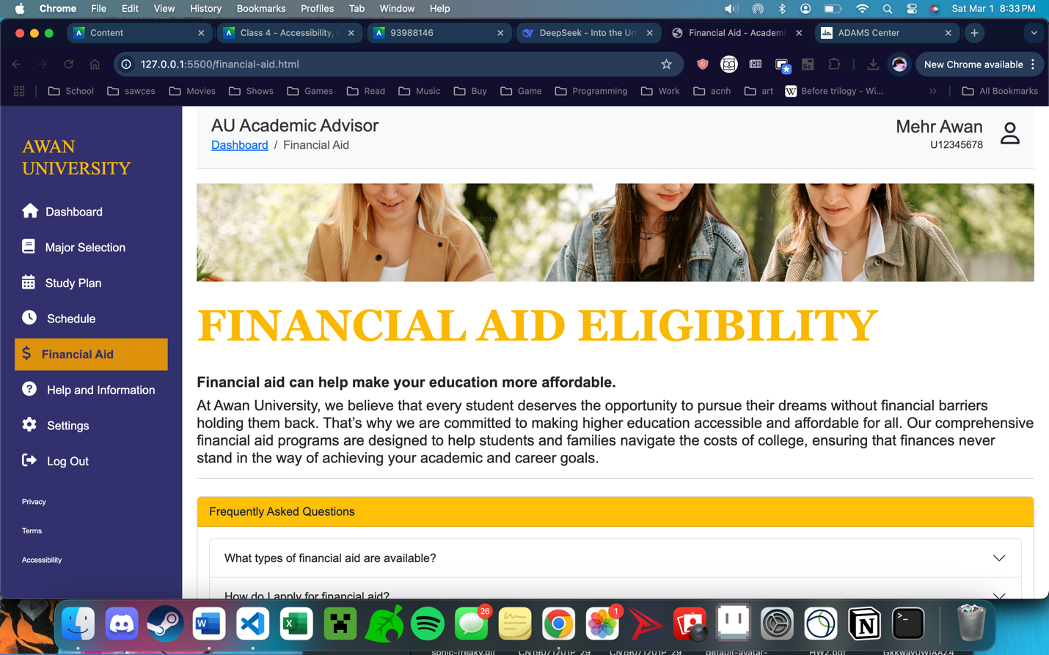

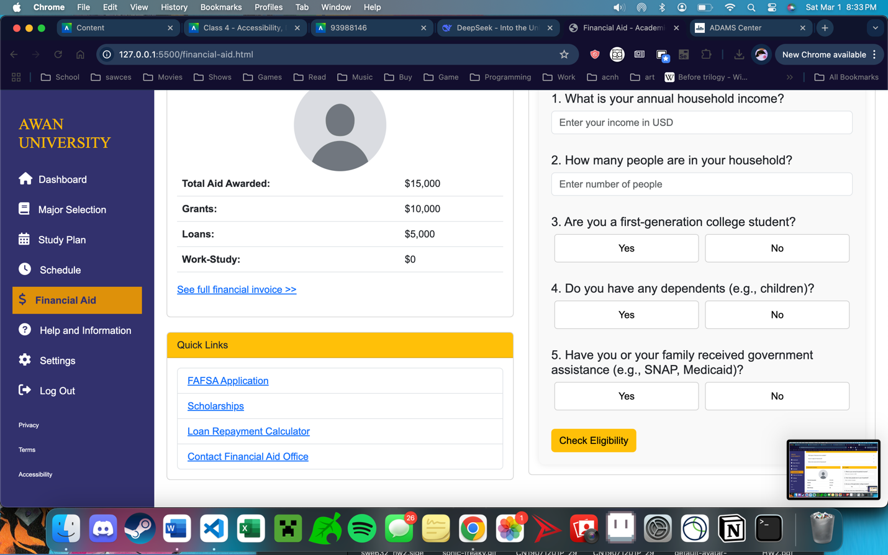

**Selenium Test Cases (attached):**

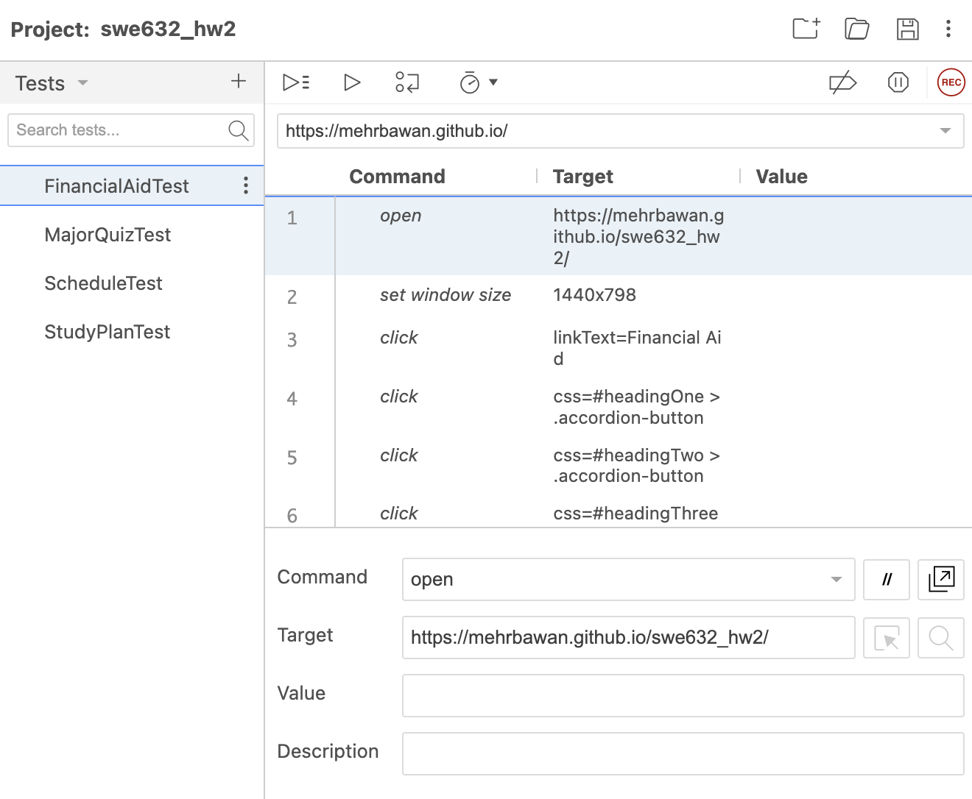

1. **Financial Aid Test:** Checks that those with low income and other requirements get the prompt “eligible for significant aid,” and those with higher income get the “aid possible” prompt, etc.
2. **Major Quiz Test:** Checks that someone expressing certain interests gets appropriate result, ex. interest in working with technology will lead to “Computer Science or Engineering” major result.
3. **Schedule Test:** Checks that proper calendar element is returned at prompt for schedule.
4. **Study Plan Test**: Checks that correct study plan is returned depending on major selected.

**Interface Metrics**

|  |  |
| --- | --- |
| **Metric** | **Examples in Project** |
| **Gulfs of Execution** | * Explicit sidebar on side at all times to show how to navigate. * Breadcrumb under header to show location in site tree * Forms have clear instructions on when to select and where to submit. |
| **Affordance** | * Buttons like "Generate Study Plan" and "Generate Weekly Schedule" are designed to look clickable/show selectability on hover. * Input fields are clear and method is evident:   + plain white box indicates input, blank buttons imply selecting one   + arrows on dropdowns/income range selector indicate expected selection method * Links are colored and underlined. |
| **Signifier** | * Appropriate icons for each sidebar heading gives idea of each page (ex. dollar sign for financial aid, home button for dashboard indicates returning to base page, etc.) |
| **Gulfs of Evaluation** | * Immediate feedback on submitting form content:   + After submitting major quiz, "Your Recommended Major" is displayed immediately underneath   + After clicking "Generate Weekly Schedule," the weekly calendar is displayed with the courses and their timings right away * Incorrect or missing input types immediately prompted (entering incorrect income in financial aid form, missing quiz values in major quiz). |

**Accessibility Considerations**

* Alt text available on all images for those who use screenreaders.
* Tab navigation possible with buttons for those who cannot use mouse.